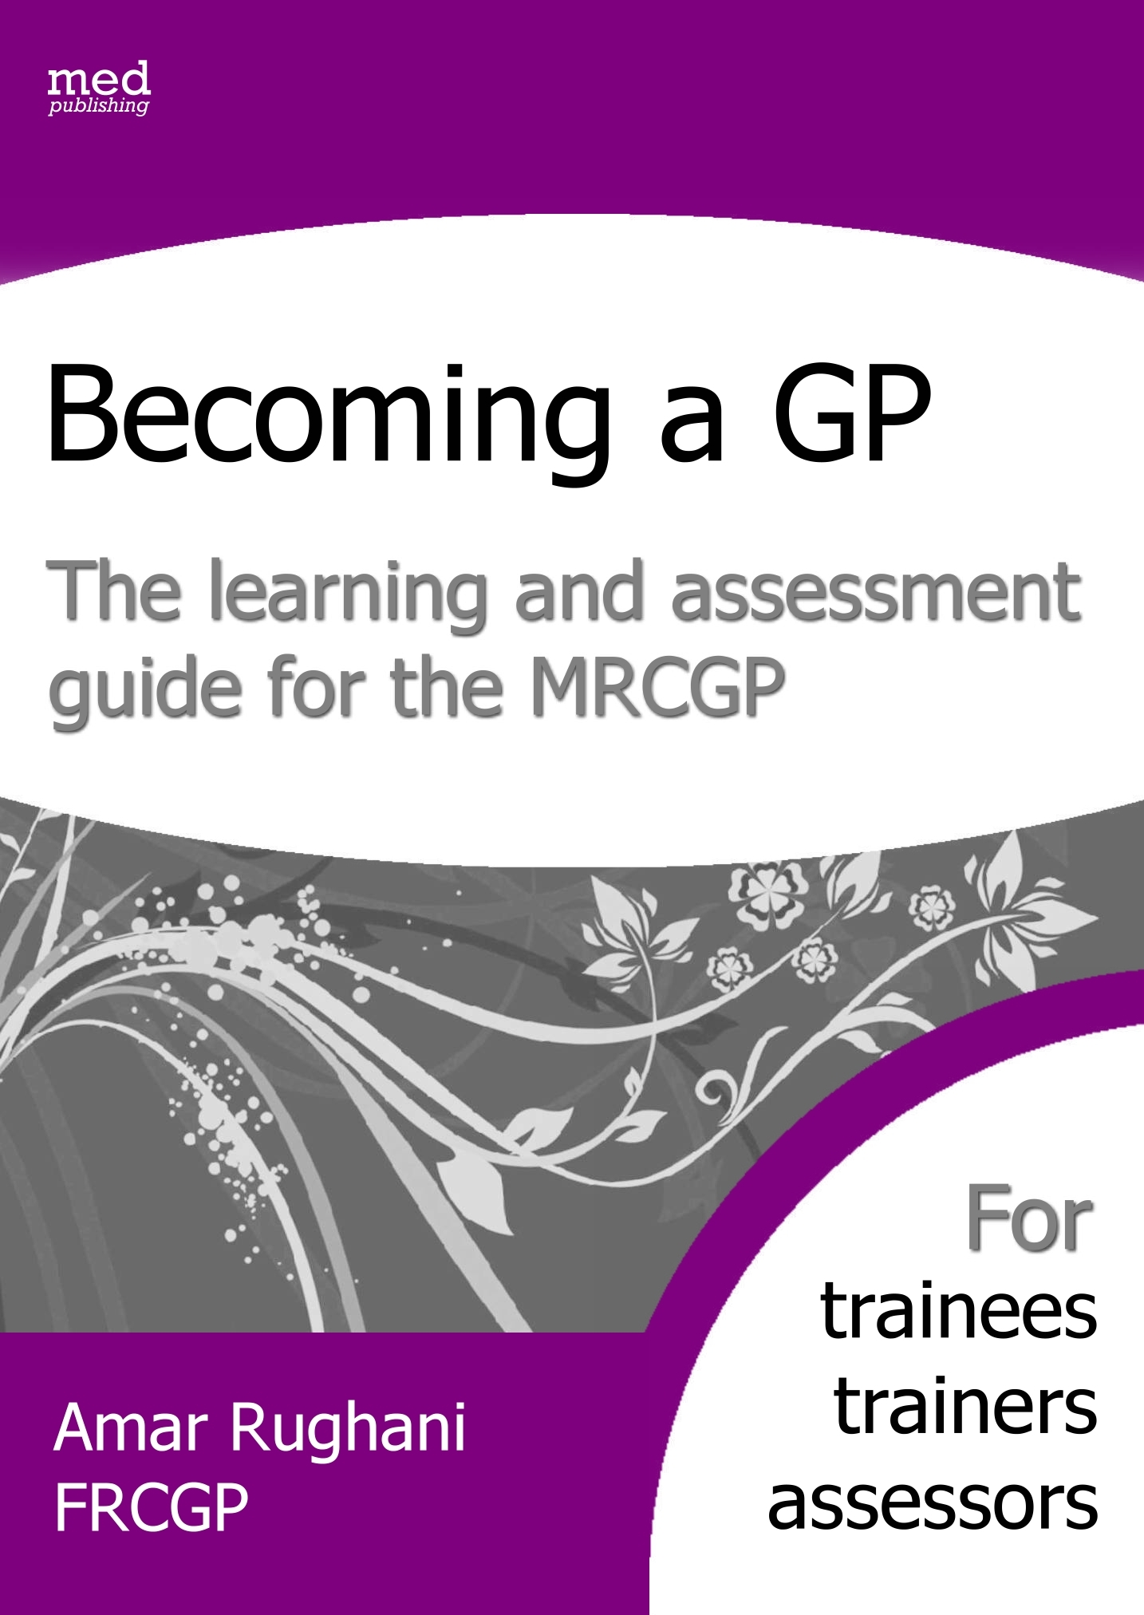

Shaded areas may not be fully evident until the final year of training  Some areas can be linked to more than one root. Where this is often the case we have used the following to suggest this **R ( link to Relationship) or **p (link to professionalism etc. |  |  | Please grade the trainee in comparison with doctors at the same stage of training |  |  |  |  | Unable to grade | Concerns?
 |  |  | Below expectations |  | Border  line | Meets expectations | Above expectations | Unable to grade | Concerns?
Relationship | Communication and consultation skills | Explores patient’s agenda and ideas, concerns & expectations
Relationship | Communication and consultation skills | Recognises the impact of the problem on the patient's life
Relationship | Communication and consultation skills | Works in partnership to negotiate a plan
Relationship | Communication and consultation skills | Explores what the patient has understood from the consultation
Relationship | Communication and consultation skills | **M Flexibly and efficiently achieves consultation tasks
Relationship | Practising holistically | Understands the patient's socio-economic/cultural background
Relationship | Practising holistically | Recognises the impact of the problem on family/carers
Relationship | Working with colleagues and in teams | Works co-operatively with team members, using their skills appropriately
Relationship | Working with colleagues and in teams | Communicates proactively with team members
Deeper features are shown below. Ring any that apply
POSITIVE NEGATIVE
- Shows interest  - Encourages contribution |  |  |  | - Shows little interest in the patient's thoughts and feelings
- Uses open questions, adjusts questioning  - Expresses ideas clearly. |  |  |  | - Uses too many closed questions  - Unable to adapt language,.  - Unclear when communicating
- Good non-verbal behaviour e.g. eye contact |  |  |  | - Lacks warmth in voice/manner
- Demonstrates team working & leadership skills |  |  |  | - Inappropriately works in isolation
- Gives constructive feedback & support |  |  |  | - Critical, confrontational, gives little support
Summary & interpretation:

Action:

Shaded areas may not be fully evident until the final year of training |  |  | Please grade the trainee in comparison with doctors at the same stage of training |  |  |  |  | Unable to grade | Concerns?
 |  |  | Below expectations |  | Border  line | Meets expectations | Above expectations | Unable to grade | Concerns?
Diagnostics | Data gathering and interpretation | Takes a history, examines and investigates systematically & appropriately**M
Diagnostics | Data gathering and interpretation | Elicits important clinical signs & interprets information appropriately
Diagnostics | Data gathering and interpretation | Makes appropriate use of existing information about the patient's problem.
Diagnostics | Making a diagnosis/  making decisions | Addresses problems that present early and in an undifferentiated way by integrating information in order to aid pattern recognition
Diagnostics | Making a diagnosis/  making decisions | Uses time as a diagnostic tool.
Diagnostics | Making a diagnosis/  making decisions | Decides what is probable and uses this to aid decision-making
Diagnostics | Making a diagnosis/  making decisions | Makes or excludes important diagnoses
Diagnostics | Making a diagnosis/  making decisions | Revises hypotheses in the light of additional information.
Diagnostics | Making a diagnosis/  making decisions | Thinks flexibly around problems, generating feasible solutions
Diagnostics | Clinical management | Formulates appropriate management plans in line with best practice
Diagnostics | Clinical management | Varies management options in response to changing circumstances.
Diagnostics | Clinical management | Refers appropriately and  co-ordinates care with other professionals
Diagnostics | Clinical management | Provides continuity of care for the patient rather than just the problem
Diagnostics | Managing medical complexity | Simultaneously manages acute and chronic problems
Diagnostics | Managing medical complexity | Tolerates uncertainty where appropriate
Diagnostics | Managing medical complexity | Addresses risk and safety-nets appropriately
Diagnostics | Managing medical complexity | Encourages health promotion
Deeper features are shown below. Ring any that apply
POSITIVE NEGATIVE
- Identifies key issues  - Prioritises appropriately  - Elicits necessary detail / routinely looks for red flags  - Rarely loses sight of wider needs of situation  - Aware of appropriate options |  |  |  | - Fails to explore important cues/overlooks important issues  - Fails to recognise the seriousness of the situation  - Shifts focus largely to immediate worries/needs  - Suggests too narrow a range of options
- Shows sound/systematic judgment **M |  |  |  | - Random/disorganised **M
- Tries to think around an issue  - Flexible and open to new ideas/possibilities |  |  |  | - Makes immediate assumptions  - Rigid
Summary & interpretation:

Action:

Shaded areas may not be fully evident until the final year of training |  |  | Please grade the trainee in comparison with doctors at the same stage of training |  |  |  |  | Unable to grade | Concerns?
 |  |  | Below expectations |  | Border  line | Meets expectations | Above expectations | Unable to grade | Concerns?
Management | Primary care administration and IMT | Uses the primary care organisational and IMT systems routinely and appropriately
Management | Primary care administration and IMT | Uses the computer during the consultation whilst maintaining rapport with the patient.
Management | Primary care administration and IMT | Keeps good medical records
Management | Community orientation | **D Identifies important characteristics of the local community that might impact upon patient care
Management | Community orientation | Encourages patients to appropriately use the community resources.
Management | Community orientation | Uses resources cost- effectively
Management | Maintaining performance, learning and teaching | Critically appraises guidelines and research evidence to inform decision-making.
Management | Maintaining performance, learning and teaching | Keeps up-to-date and shows commitment to addressing learning needs
Management | Maintaining performance, learning and teaching | Participates and learns from audit and significant event reviews
Management | Maintaining performance, learning and teaching | Completes learning cycles and routinely learns from reflection
Management | Maintaining performance, learning and teaching | Contributes to the education of students and colleagues
Deeper features are shown below. Ring any that apply
POSITIVE NEGATIVE
- Thinks ahead, plans effectively |  |  |  | - Fails to think ahead, plan and think about knock-on effects
- Co-ordinates activities |  |  |  | - Disorganised **p
- Remains calm under pressured conditions |  |  |  | - Unable to cope with challenging situations
- Delegates appropriately / seeks help when necessary |  |  |  | - Inappropriately tries to deal with situation alone
- Delivers on time |  |  |  | - Misses reasonable deadlines
- Regularly updates skills |  |  |  | - Doesn’t have a system for keeping up to date
Summary & interpretation:

Action:

Shaded areas may not be fully evident until the final year of training |  |  | Please grade the trainee in comparison with doctors at the same stage of training |  |  |  |  |  | Unable to grade | Concerns?
 |  |  | Below expectations | Border  line |  | Meets expectations | Above expectations |  | Unable to grade | Concerns?
Professionalism | Maintaining an ethical approach to practice | Shows awareness of own values, attitudes and ethics and how these might influence professional behaviour.
Professionalism | Maintaining an ethical approach to practice | Identifies and discusses ethical conflicts
Professionalism | Maintaining an ethical approach to practice | Shows respect for others
Professionalism | Fitness to practise | Understands and maintains awareness of the GMC duties of a doctor
Professionalism | Fitness to practise | Responds to complaints appropriately
Professionalism | Fitness to practise | Takes appropriate responsibility for decisions and actions
Professionalism | Fitness to practise | Ensures work-life balance protects professional obligations & personal health
Deeper features are shown below. Ring any that apply
POSITIVE NEGATIVE
- Demonstrates adequate respect for others  - Is non-judgemental & fair |  |  |  |  | - Lacks sufficient respect for others  - Shows prejudice
- Positive/enthusiastic when dealing with problems |  |  |  |  | - Treats issues as problems rather than challenges
- Able to admit mistakes/learn from them |  |  |  |  | - Avoids taking responsibility for poor decisions/ideas
- Committed to equality of care for all |  |  |  |  | - Shows favouritism
- Backs own judgment appropriately |  |  |  |  | - Colludes with the patient's preferences when it is not in the patient's best interest to do so
- Respects importance of meeting all requirements of the organisation |  |  |  |  | - Puts insufficient effort into fulfilling certain obligations (e.g., meeting deadlines, producing documentation etc)
Summary & interpretation:

Action:

Using the performance screening forms

This screening form brings together the seminal features of the MRCGP competency framework and a number of deeper features informed by sources including the competencies tested at selection to GP specialist training¹, the core competencies of the clinical skills examination and the GP Curriculum.

Most importantly, the form clusters elements of performance in four discrete domains described by Tim Norfolk’s RDM-p model of medical performance². This model is readily understandable to those who are not trained assessors and can be applied to all medical disciplines. Tim describes medical practice as “a subtle interaction between three core activities: Relationship, Diagnostics & Management, and the quality of this interaction is heavily dependent on the professionalism underpinning it. Thus: ‘Relate to someone, diagnose their needs, manage the process & at all times ensure you act professionally’ (hence RDM-p).”

So in the top section of this form, working from left to right and using the Relationship domain as an example, we see:
The cluster area (relationship)
The relevant performance areas from the competence framework (communication & consulting skills, practising holistically, working with colleagues and in teams)
The key word pictures for each of the performance areas

There is a rating scale that can be used by assessors or by trainees for self-assessment. The wording of the scale suggests that comparisons are made with doctors at the same stage of training. For doctors at the end of training, the standard will be the ‘competent for licensing’ standard described in the word pictures that you will find in the large arrows of this book. For doctors at an earlier stage of training, the expected standard will be either at the level described by ‘needs further development’ or between and this and the ‘competent’ level.

Some competencies are more advanced and therefore unlikely to be developed until late on in training and these are shaded grey on the form.

In the middle section, the deeper features are listed with positive ones on the left and negative ones on the right. Positive behaviours need to be seen repeatedly and in a variety of contexts if we are to be sure that they are truly embedded and not just a fluke. The negative behaviours should not be thought of as being ‘one strike and your out’ offences but if any of them are seen, they should not be ignored. If a negative behaviour occurs once, it should be noted. If it is seen again, it should be regarded as a red flag and should prompt us to be concerned and to explore this area of performance in more detail.

In the bottom section, the summary and interpretation can be written after which any action points can be noted. The interpretation may include any learning needs that have been identified. The action might include any further training or assessment that might be required.

Performance can be quickly and repeatedly screened

Using the screening forms performance can be repeatedly gauged throughout training both by assessors and by learners themselves. One approach is as follows:
Performance can be quickly and repeatedly screened

The first step is to conduct a brief screen of performance using the screening forms.
The screening forms represent the four RDMp clusters and it is worth screening all
four areas rather than one at a time as the clusters are interrelated and affect each
other as shown in figure 1.

The second step is to look for links between related areas. The material that has been
brought together in each form can help you with this. To take an example from the
screening form for Diagnostics, if a doctor routinely over-investigated, we might
mark them down on the following competency:

‘Takes a history, examines and investigates systematically & appropriately’

We might also expect such a doctor to have difficulty with the competency:

‘Tolerates uncertainty where appropriate’

If there was a mismatch in performance between the two, this might prompt further discussion. For example, if the doctor was over-investigating and yet was thought to be tolerating uncertainty, we might ask whether we need to look more closely at the latter.

The third step is to look at the deeper features. How do these correlate with what has
been shown from the competency rating? To take an example from the screening form
for Professionalism, a doctor might be thought to have difficulties with the following
competencies:

‘Is organised, efficient and takes appropriate responsibility’
‘Deals appropriately with stress’

The deeper features that underlie this area of performance might suggest why this might be. For example:

Able to admit mistakes/learn from them
Backs own judgment appropriately
Recognises own limitations and can compromise
Able to seek help when necessary

We can see from this how the screening forms can be used to investigate and diagnose a problem at a competency level and also at a deeper level of performance.

Because RDMp areas do not stand alone but overlap with each other, the next step
might be to look at problems shown up in one cluster and check for problems in
associated areas. For example, Relationship & Diagnostics overlap with each other,
particularly in the area of data gathering & interpretation.

If the doctor had problems with data-gathering we could look at the Diagnostics screening form where we might see that the doctor had problems with the following deeper features:

Didn't do this: Elicits necessary detail
Did this: Fails to explore important cues/overlooks important issues

This might prompt us to look at the screening form for Relationship. By completing this form, concerns might arise over the deeper features because the doctor:

Didn't do this: Non-judgemental, shows interest and understanding, encourages contribution
Did this: Makes assumptions, authoritarian, lacks warmth in voice/manner

This exercise would help us to see that the data-gathering problem was not really tied in with a lack of diagnostic expertise, but was more likely to be due to a lack of interest in encouraging sufficient information from the patient.

Amar Rughani

¹ Patterson F, Ferguson E, Lane P, Farrell K, Martlew J & Wells A. A competency model for general practice: implications for selection, training, and development. BJGP 2000, 50, 188 - 193.

² Quality in Primary Care 2009; 17(1):37-47. A unifying theory of clinical practice: Relationship, Diagnostics, Management and professionalism (RDM-p). Norfolk T, Siriwardena AN.

I am grateful to Tim Norfolk for reviewing the original form and suggesting a few changes, which have been incorporated into this revised version.

